## Bloodbridge:OptimizingLifesaving Resources

**Prepared For** Smart-Internz **CloudPractitioner** Guided project

## By

Shubham Madhukar Mali DYPatilAgricultureandTechnicalUniversityTalsande

## On

3July2025

## Abstract

BloodBridge is an AWS-powered solution designed to optimize the end-to-end lifecycle of bloodmanagementfromdonationtotransfusion.Itintroducesreal-timetracking,automated request processing, and robust data handling to improve emergency responsiveness and reduce wastage.

 

## FinalProjectReport

TableofContents

Introduction 3

ProjectInitializationandPlanningPhase 4

SystemArchitectureDocument 5

SystemArchitectureDiagram 5

ProjectProposal(ProposedSolution) 6

InitialProjectPlanning 7

AWSServicesUtilized 9

ApplicationDeploymentSteps 10

Advantages&Disadvantages 13

Conclusion 15

FutureScope 16

# Introduction

In the ever-evolving landscape of healthcare, timely and efficient access to lifesaving resourcesremains acriticalpriority.Amongthese, theavailabilityanddistributionofblood productsstandattheforefrontofemergency androutinemedicalcare.However,traditional bloodbanksystemscontinuetofacesignificantoperationalchallenges—includingoutdated inventory methods, disconnected stakeholders, and delayed response times—leading to avoidable fatalities and resource wastage.

BloodBridgeaimstorevolutionizethisecosystembydeliveringanintelligent,cloud-native blood management platform that harnesses the power of AWS services. Designed with scalability, security, and real-time responsiveness in mind, BloodBridge serves as a digital bridge between donors, hospitals, blood banks, and administrators. Through its innovative architecture and technology-driven workflows, the platform enables automated donor tracking, demand forecasting, and seamless request fulfillment—all while ensuring data security and compliance with healthcare regulations.

1. Purpose

The primary objective of BloodBridge is to create a centralized, intelligent, and accessible system that manages the lifecycle of blood collection, storage, and distribution. By integratingreal-timedataprocessingwithscalablecloudservices,thesystemensuresthatthe right type and quantity of blood reaches the right place at the right time, thereby improving patient outcomes and operational efficiency.

1. Scope

Thisproject encompasses:

* + Aweb-basedinterfacefordonorregistration,hospitalrequests,andinventory dashboards.
  + Backendservicesforhandlingrequestworkflows,role-basedaccess,anddata processing.
  + IntegrationwithAWScloudinfrastructureforcompute,storage,security,and analytics.
  + AscalableandmodulararchitecturetosupportfutureenhancementslikeAI-based demand prediction and mobile app integration.

1. Significance BloodBridgeaddressesthefollowingpressingissues:
   * Emergencybloodshortagesduetopoorvisibilityand coordination.
   * Manualdatamanagementleadingtodelaysandinaccuracies.
   * Lackof areal-time,secure,andunifiedsystemconnectingallstakeholders.
   * Limitedtechnologicaladoption insmalland mediumblood centers. Byintroducingthisplatform,weaimtoempowerhealthcareproviderswithtoolsthatensure faster response times, reduce operational overhead, and enhance donor and recipient experiences. The solution contributes toward achieving the broader goal of saving lives through timely access to vital blood resources.

# ProjectInitializationandPlanningPhase

**ProblemStatements**

|  |  |  |  |  |  |
| --- | --- | --- | --- | --- | --- |
| **PS**  **No.** | **I am (Customer)** | **I’mtryingto** | **But** | **Because** | **Whichmakesme feel** |
| PS- 1 | A hospital administrator (Sarah) | Request rare bloodurgently during emergency | It takes too longtofind matching donors | Manual coordinationis slow | Helpless and anxiousinsaving patient lives |
| PS- 2 | A regular donor(John) | Manageand schedulemy blood donations | I’mnotsure when I’m eligible or whereto go | I don't get updates on nearbydonation drives | Disconnectedfrom helping regularly |
| PS- 3 | A blood bank manager(Lisa) | Update and broadcastreal- timeinventory | My current system  doesn’tsync across hospitals | No centralized, real-timeupdate tool | Frustrated and worried about mismanagement |

# SystemArchitectureDocument

##### Components:

1. **ApplicationLayer:**
   * Hostedon**AmazonEC2**instances• RESTfulAPIsusingNode.js/Python

##### DataLayer:

* + **Amazon RDS:** Relational data (users, hospitals) • **AmazonDynamoDB:**Real-time blood stock data

##### Storage:

* + **AmazonS3:**Reports,documents, images

##### Authentication:

* + **AmazonCognito**forsecurelogin&sessionmanagement

##### Monitoring:

* + **AWSCloudWatch** forsystem logs
  + **AWSCloudTrail**forAPIaccess tracking **ArchitectureFlow:** User>APIGateway>Lambda/EC2>RDS/DynamoDB>S3

# SystemArchitectureDiagram

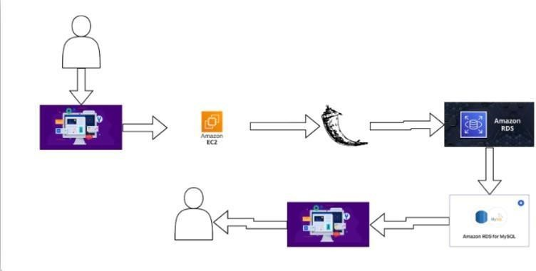

# ProjectProposal(ProposedSolution):

BloodBridgeisacloud-nativeapplicationthat:

* UsesAWStohostareliable,scalableinfrastructure.
* OffersRESTAPIsfordonorregistration,inventoryupdates,andrequestmanagement.
* Providesreal-timeaccesstobloodproductavailability.
* Implementssecureloginandrole-basedaccessfordonors,staff,andhospitals.

**Features:**

* Real-timeInventoryDashboard
* DonorManagementSystem
* RequestFulfillmentWorkflow
* Role-BasedAccess(Donor,Hospital,Admin)
* AuditLogsand Monitoring
* SecureData Handling

**Benefits:**

* Fasterbloodavailability
* Reducedwastage
* Improvedemergencyresponse
* Seamlesscoordinationbetweenstakeholders

### InitialProjectPlanning:

**ProductBacklog,SprintSchedule,andEstimation(4Marks)**

|  |  |  |  |  |  |  |  |
| --- | --- | --- | --- | --- | --- | --- | --- |
| **Sprint** | **Functional Requirement (Epic)** | **User Story Number** | **UserStory/ Task** | **Story Points** | **Priority** | **Sprint Start Date** | **Sprint EndDate (Planned)** |
| Sprint- 1 | User Onboarding& Role Setup | USN-1 | As a user (donor/hospital),I can register and choose my role. | 3 | High | 13  May 2025 | 15 May  2025 |
| Sprint- 1 | Authentication Integration | USN-2 | Asauser,Ican securely log in using AWS Cognito. | 3 | High | 16  May 2025 | 17 May  2025 |
| Sprint- 1 | Blood Inventory Input | USN-3 | Asabloodbank staff,Icanenter blood stock details into the system. | 3 | High | 18  May 2025 | 19 May  2025 |
| Sprint- 2 | BloodRequest Workflow | USN-4 | As a hospital, I can request a specific blood typeandseereal- time availability. | 4 | High | 20  May 2025 | 23 May  2025 |
| Sprint- 2 | Notification System | USN-5 | Asadonor,Ican receive notifications when blood is needed in my area. | 3 | Medium | 24  May 2025 | 25 May  2025 |
| Sprint- 3 | Dashboardfor Admin | USN-6 | As an admin, Icanviewallblood stocks, requests, and user activity. | 5 | Medium | 26  May 2025 | 30 May  2025 |
| Sprint- 3 | Audit &Logging (CloudWatch) | USN-7 | As a developer/admin, I can track all operations and events using CloudWatch. | 2 | Medium | 31  May 2025 | 01 June  2025 |
| Sprint- 4 | UI/UX  Enhancements | USN-8 | As a user, I can interact with a clean,responsive | 3 | Low | 02  June 2025 | 03 June  2025 |

|  |  |  |  |  |  |  |  |
| --- | --- | --- | --- | --- | --- | --- | --- |
|  |  |  | interface. |  |  |  |  |
| Sprint- 4 | Deployment Automation | USN-9 | As a DevOps engineer,Ican deployupdates via CI/CD pipelines. | 2 | Medium | 04  June 2025 | 05 June  2025 |
| Sprint- 4 | Final Integration Testing | USN-10 | As a QA, I can run end-to-end teststovalidate all workflows. | 3 | High | 06  June 2025 | 07 June  2025 |
|  | ReserveBuffer  /Contingency Time | — | For unexpected changes,fixes,or rollout support. | — | — | 08  June 2025 | 13 June  2025 |

# AWSServicesUtilized

##### AmazonS3(SimpleStorage Service)

* + Description: Amazon S3 is used for secure and scalable storage of blood inventory data,reports,andassociateddocuments(e.g.,donorcertifications,auditlogs,hospital requests).
  + UseCaseinBloodBridge:Storesuploadedforms,bloodtestreports,system- generated logs, and images. Provides versioning and durability.

##### AmazonEC2(ElasticCompute Cloud)

* + Description:EC2providesresizablecomputecapacityinthecloud,actingasvirtual servers to host backend logic, APIs, and process-intensive operations.
  + UseCaseinBloodBridge:HoststheRESTAPIbackend,handleshospital-donor matching logic, processes data queries, and connects securely to databases.

##### Amazon DynamoDB

* + Description:AfullymanagedNoSQLdatabasethatdelivershigh-performance read/write throughput with low latency at scale.
  + UseCaseinBloodBridge:Usedforreal-timebloodinventorytracking,donation history, and blood type availability. Optimized for speed and high-availability scenarios.

##### AmazonRDS(RelationalDatabaseService)

* + Description: A managed relational database service that supports MySQL, PostgreSQL,andmore.Itprovidessecurity,scalability,andbackupmanagement.
  + UseCaseinBloodBridge:Storesstructureddatalikeusercredentials,donor-recipient profiles, blood request logs, and access control records.

# ApplicationDeploymentSteps

Deploying the BLOODBRIDGE application involves a systematic series of steps to ensure reliableperformance,security,andscalabilityonAWSinfrastructure.Belowisabreakdown of the key deployment stages:

##### Step1:LocalDevelopment–CodeCompilation& Testing

* + TheBLOODBRIDGEapplicationisfirstdevelopedandtestedinalocaldevelopment environment using appropriate tools (e.g., Node.js, React, Python, etc.).
  + Developersvalidatefunctionalitythroughunittests,localbuilds,andstaticcode analysis.
  + Configurationfilessuchasenvironmentvariables,.envfiles,andresourcedefinitions are prepared for deployment.

##### Step2:AutomatedDeploymenttoAWS

* + Oncethecodebaseisvalidatedlocally,deploymentisinitiatedusingautomationtools like AWS CLI, CodeDeploy, or Terraform scripts.
  + Application files, including frontend builds, backend APIs, and configuration templates,arepushedtocorrespondingAWSservicessuchasEC2,Lambda,orS3.

##### Step3:ConfigurationofAWSServices

* + AWSservices areconfiguredforoptimalperformanceandsecurity:
    - EC2instancesareprovisioned forbackendAPIhosting.
    - AmazonRDSandDynamoDBareconfiguredwithcorrectschemas androles.
    - IAMroles,securitygroups,VPC settings,andauto-scalingrulesare defined.

##### Step4:StagingEnvironmentTesting

* + Astaginginstanceoftheapplicationisdeployedtosimulatetheproduction environment.
  + Functionaltesting,integrationtesting,andperformancemonitoringareconductedto verify stability.
  + Loadtestingmaybeperformedtoassessthesystem’sbehaviorunderreal-world conditions.

##### Step5:ProductionRelease

* + Uponsuccessfulstagingvalidation,theBLOODBRIDGEapplicationisdeployedto the production environment.
  + DNSrouting,HTTPSconfigurations,andaccesscontrolsarefinalized.
  + Theapplicationbecomes accessibleto usersviatheliveURLorhosted endpoint.

1.Results

6.1 Output Screenshots

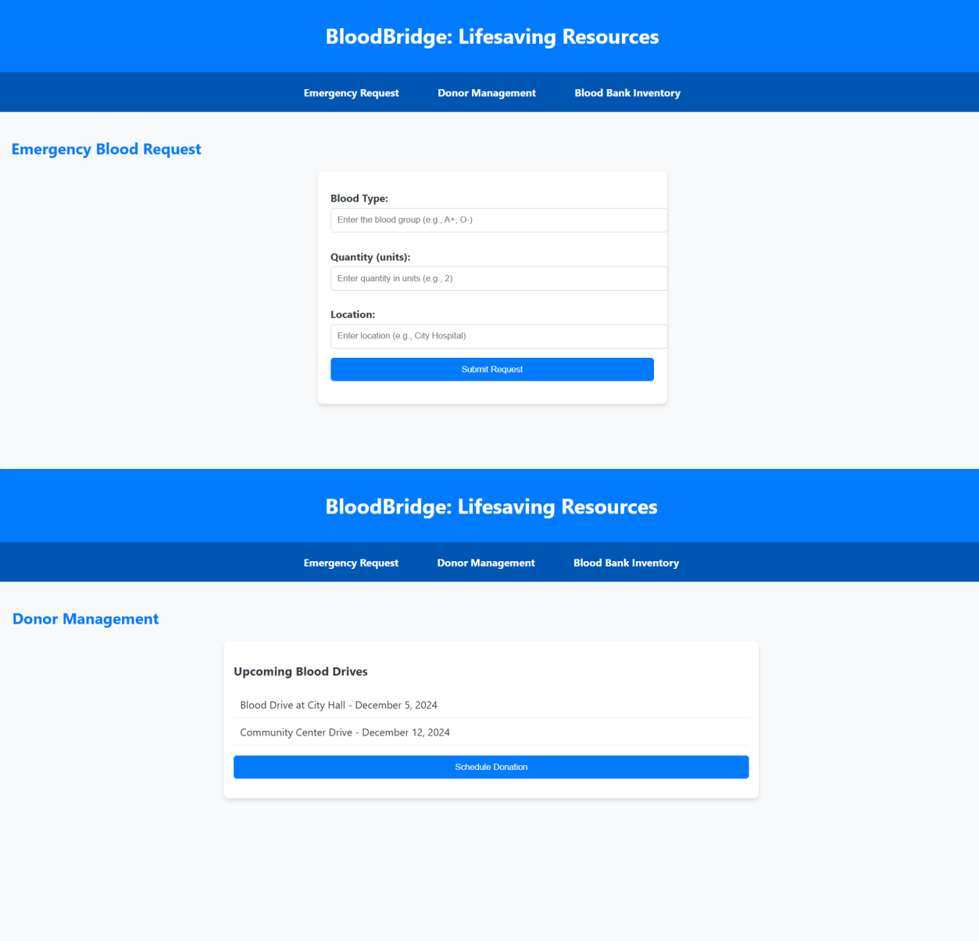

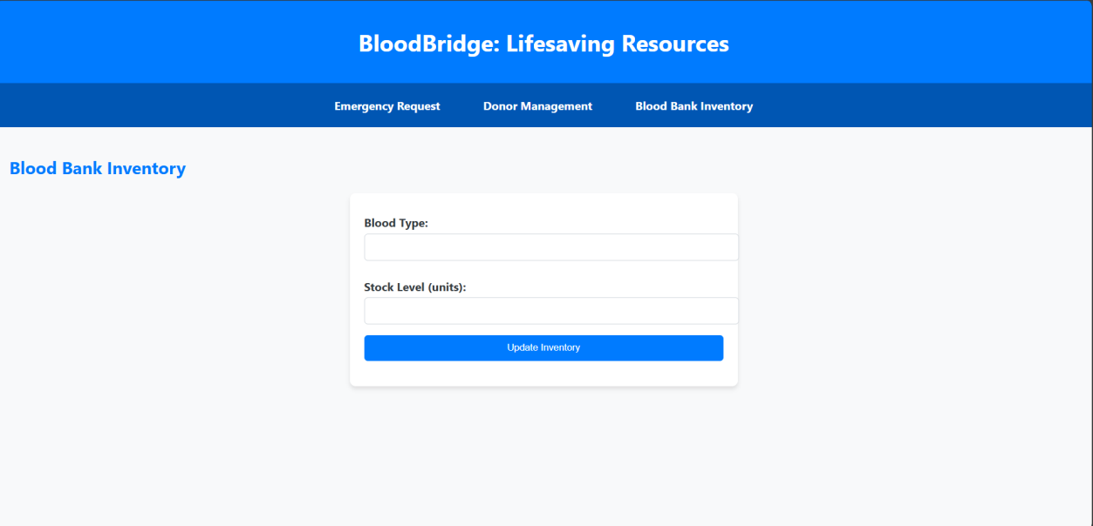

# Advantages&Disadvantages:

#### Advantages:

1. Real-timeInventoryVisibility

BloodBridgeprovideshospitalsandadministratorswithreal-timevisibilityintoblood stock levels, types, and expiration dates, enabling quicker decision-making and reducing delays in emergencies.

1. CentralizedData Management Theplatformunifiesdisparatesystemsacrosshospitals,donors,andbloodbanksinto a single cloud-native infrastructure, eliminating redundancy and improving coordination.
2. ScalabilityandReliabilitywithAWS LeveragingAWSservicessuchasEC2,Lambda,RDS,DynamoDB,andS3ensures high availability, auto-scaling, disaster recovery, and compliance with healthcare standards.
3. EnhancedEmergency Response

Throughreal-timerequestfulfillmentandsmartrouting,hospitalscanrespondfaster to critical needs, potentially saving lives during trauma and surgery cases.

1. Role-BasedSecurityandAccessControl WithAmazonCognitoandIAMpolicies,theplatformofferssecureauthentication and authorization, protecting sensitive health and donor data.
2. ImprovedDonorEngagement Donorscanregister,tracktheircontributions,andreceivenotificationsviathe web/mobile interface—fostering continuous involvement and loyalty.
3. ReductioninBlood Wastage Byenablinghospitalstoforecastdemandandensuringthatbloodunitsareused before expiration, the system contributes to a significant reduction in wastage.
4. ModularandExtendable Design

FuturefeaturessuchasAI-basedprediction,chatbotintegration,andmobileapp extensions can be added seamlessly.

#### Disadvantages:

1. Dependenceon Internet andCloudServices

Beingacloud-hostedsolution,thesystemrequiresreliableinternetconnectivity. Disruptions in connectivity could affect access during critical moments.

1. InitialSetup&Integration Effort Hospitalsandbloodbanksmayneedtechnicalsupportduringonboardingandsystem integration with existing infrastructure.
2. LearningCurveforStaff

Non-technicalstaffmayfacealearningcurvewhiletransitioningfrommanual workflows to a digital platform, requiring training and change management.

1. OperationalCostsonAWS WhileAWSoffersscalabilityandreliability,itsusagebeyondfree-tierlimitsincurs recurring costs depending on compute time, storage, and traffic.
2. DataPrivacy andCompliance Risks

Despitebuilt-insecurity,storinghealth-relateddataonthecloudalwaysdemands rigorous compliance with laws like HIPAA or local data protection acts.

1. LimitedOffline Functionality Featuresareheavilyreliantonlivecloudinteractions,andthesystemmaynot function optimally in regions with low or unstable internet coverage.

# Conclusion:

BloodBridgerepresentsatransformativestepforwardintherealmofhealthcaretechnology, specifically addressing the inefficiencies and risks prevalent in traditional blood bank management systems. By leveraging a robust, scalable, and secure cloud infrastructure powered by AWS, the platform not only digitizes blood inventory processes but also facilitates real-time coordination among critical stakeholders—donors, hospitals, and administrators.

The integration of modern cloud-native technologies such as Amazon EC2, Lambda, RDS, DynamoDB, S3, and Cognito ensures that Blood Bridge is equipped to deliver high availability, secure access, and data-driven decision-making in mission-critical scenarios. Throughfeatureslikereal-timedashboards,automatedrequestmanagement,andaudit-ready monitoring, the platform significantly reduces delays, enhances donor engagement, and improves emergency response efficiency.

Blood Bridge’s modular and extensible architecture lays the groundwork for future innovation, including AI-driven demand forecasting, mobile accessibility, and intelligent conversationalinterfaces.Theseadvancementswillenablethesystemtoevolvecontinuously with healthcare needs and technological progress.

In conclusion, Blood Bridge is not just a solution to the existing operational challenges in blood distribution—it is a proactive digital infrastructure designed to save lives. By streamliningcoordinationandenhancingresponsiveness,BloodBridgesetsanewbenchmark for modern blood bank systems in both public and private healthcare sectors.

# FutureScope

The BloodBridge project is designed with scalability and long-term impact in mind. As the healthcarelandscapeevolvesanddigitalinfrastructurebecomesmorecentraltopublichealth, BloodBridge can expand in the following ways:

1. AI-BasedDemandPrediction:
   * Integratemachinelearningalgorithmstoforecastblooddemandbasedon historical trends, regional patterns, seasonal diseases, accident rates, and public events.
   * Preventshortagesoroversupplybyproactivelymanaginginventorylevels.
2. MobileApplicationfor Android&iOS:
   * Providereal-timeupdatesfordonorsand hospitals.
   * Enableinstantnotificationsforurgentrequestsordonationopportunities.
   * IntegrateGoogleMapsfornearbydonationcampsorbloodbanklocations.
3. IntegrationwithHospitalInformationSystems(HIS):
   * AutomaticallysyncpatienttransfusionneedswithBloodBridge.
   * Enhanceworkflow automationandreducemanualentryerrors.
4. BlockchainforDonor Identity&DonationHistory:
   * Usedecentralizedledgerstosecurelystoredonorprofiles,donationfrequency, and medical history.
   * Ensuredataintegrityand traceabilityacross institutions.
5. Real-TimeLogisticsandDeliveryIntegration:
   * Partner with emergency services and logistics providers to track blood unit transportationinreal-timeusingIoT-enabledtemperaturesensorsandGPS.
6. VoiceandChatbotIntegration:
   * ImplementAI-powered assistantsforvoicequeriesandautomated responses.
   * Guidedonorsthrougheligibility checks,FAQs,and registration.
7. MultilingualSupport:
   * Localizetheapplicationtoregionallanguagesforbetteraccessibilityand adoption across diverse populations.
8. GovernmentHealthPlatform Integration:
   * Collaboratewithnationalbloodservicesandhealthportalstoformaunified, country-wide donation and request network.
9. CSR&Volunteer Management:
   * AllowNGOs,colleges,andcompaniestoorganizedonationdriveswith scheduling, attendance tracking, and impact metrics.
10. AnalyticsDashboardforAdministrators:
    * Provideinsightsintodonordemographics,regionaldemandtrends,andblood utilization to support data-driven policymaking.

# Appendix

SourceCode:-[ [Cloud-BloodBridge-source code](https://github.com/Anuradha-123kashid/Cloud-BloodBridge.git) ]

DemonstrationVideoLink:-[ [CloudBloodBridgeDemonstrationVideoLink](https://drive.google.com/file/d/1b5ojySe5mtffKPGMorfQ-exuCNJkiOpr/view?usp=sharing) ]